New Burn Pit Registry Aims for Data on 4.7 Million Veterans to Assist in Research on Exposure to Hazards

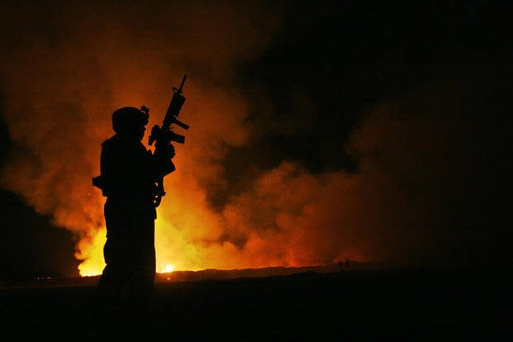
Sgt. Robert B. Brown from Fayetteville, N.C. with Regimental Combat Team 6, Combat Camera Unit watches over the civilian firefighters at the burn pit as smoke and flames rise into the night sky behind him on May 25, 2007. (Samuel D. Corum/U.S. Marine Corps)
Military.com | By Patricia Kime
Published August 01, 2024 at 11:17am ET
The Department of Veterans Affairs has overhauled its registry for veterans exposed to burn pits and other airborne hazards overseas, working with the Defense Department to include 4.7 million veterans who served in locations with potentially dangerous air quality.
The VA announced Thursday that the new Airborne Hazards and Open Burn Pit Registry, which includes basic information on veterans as well as deployment history, will advance scientific research on the health effects of exposure overseas to smoke, sand, chemical fires and fine particulate matter.
VA officials called the new database an "important research tool that enables VA to identify and study health challenges" of the veteran and service member population.
Read Next: Space Force's Enlisted Leader Seeks Hollywood Star Power to Put Guardians on Screen
"What we're talking about is an update to ... our burn pit registry, which is a way for veterans to contribute to research that will help us determine what new conditions we should be considering as connected to burn pits in the future," Under Secretary for Health Dr. Shereef Elnahal said during an interview Tuesday with Military.com.
"Veterans have traditionally participated in VA research for many, many years because they know that participation will help other veterans into the future," he said.
Military.com Top Headlines
The top headlines from Military.com for August 2, 2024.
Share
PauseNext playlist item
Unmute
Current Time 0:51
/
Duration 3:32
Loaded: 55.99%

Fullscreen
To create the new database, the VA and DoD pulled deployment data for millions of veterans who served in certain locations during specific time periods when they may have been exposed to toxic conditions, such as oil well fires, chemical plumes, burn pits, nerve agents and other hazardous materials.
The registry will include military personnel information; demographics such as gender, race and ethnicity; and deployment locations. It will not include medical information or any data related to VA benefits, according to Elnahal.
The new registry is vastly different from the one created by the VA in 2014 after Congress required the department to establish a registry to monitor the health of veterans with potential exposure.
That initiative was troubled from the start, with the VA opposing its creation, saying it had little value because the connection between burn pits and illnesses was unproven.
And advocacy groups that had lobbied for a VA registry -- like Burn Pits 360, which had created its own account of sick veterans -- despised its final form: a lengthy application that explored veterans' personal habits, such as smoking, that could be cited as a source for illness; a voluntary physical exam; and no pathway for adding deceased veterans.
"Our idea of an effective registry should include tracking mortality data and the option to update information if there is a decline in health," Rosie Torres, co-founder of the Texas-based Burn Pits 360, wrote in an email to Military.com. "A registry isn't just about policy reform but about understanding the health impacts of deployment exposures."
In 2022, the National Academies of Sciences, Engineering and Medicine concluded that the registry was "not helpful" and suggested the resources spent on the database should be used for an improved patient surveillance system and research platform.
The panel also noted that the registry didn't allow for updating by the veterans, making it useless from a health surveillance standpoint for tracking individuals' health issues across their lifetime. And it was never used to guide policy decisions.
Following that report, the VA decided to revamp the registry, resulting in the new database that is now live, according to Elnahal.
Researchers who want to use the database to understand health consequences and need the information to be linked to clinical data will have to submit their studies for review. If the research extends beyond population-level analysis and requires disclosure of veterans' identities, they will be asked for consent, Elnahal said.
The database will include all veterans, living and deceased, who were determined by the DoD to have deployed to eligible locations.
"Understand that the moves we're making here will assist in our efforts to identify more presumptive conditions into the future, and that obviously would lead to more benefits to more veterans," Elnahal said.
"This redesign massively expands the registry and reduces the participation requirements for veterans, paving the way for critical research in the coming years," he said in a statement.
The VA did not say how many of the 4.7 million veterans eligible for the registry were enrolled in the previous version. As of October 2022, that registry contained roughly 370,000 veterans, with another 130,000 who started the process but did not finish the questionnaire.
Of those who had completed registration, just 30,000 had undergone the medical exam.
The new registry will include veterans who served in the following campaigns or combat theaters, according to the VA and DoD:
- Desert Shield and Desert Storm; Iraqi Freedom; Enduring Freedom; and New Dawn.
- Iraq, Afghanistan, Kuwait, Saudi Arabia, Bahrain, Djibouti, Gulf of Aden, Gulf of Oman, Oman, Qatar, United Arab Emirates, waters of the Persian Gulf, Arabian Sea, Red Sea, Syria, Uzbekistan and Egypt between Aug. 2, 1990, and Aug. 31, 2021.
- Somalia since Aug. 2, 1990.
- The Southwest Asia theater of military operations and Egypt any time after Aug. 2, 1990.
- Afghanistan, Djibouti, Jordan, Lebanon, Syria, Uzbekistan or Yemen any time after Sept. 11, 2001.
- Associated airspaces with the countries listed above, as well as the waters of the Persian Gulf, Arabian Sea, Gulf of Aden, Gulf of Oman, and the Red Sea.
Veterans also can opt out of the registry by completing an online form.
Elnahal said the department worked with veterans service organizations and affected veterans to create the new database. VA and DoD officials hope veterans will not opt out, given the potential for breakthrough research in the coming years.
"Being part of the registry is a way for individuals to help and improve our understanding of the challenges faced by service members and veterans affected by these exposures," Assistant Secretary of Defense for Health Affairs Dr. Lester Martinez-Lopez said in a statement.
Torres added that tracking mortality data and health issues in this group of veterans should be a top priority for the VA.
"Failing to collect and track this data [would be] continued gaslighting from the VA and DoD," Torres said.
Related: Hundreds of Thousands of Vets Have Filed Claims as Pact Act Celebrates 1st Year
Related Topics: Military Headlines Department of Veterans Affairs - VA Department of Defense - DoD Veterans

